Fusion Model Accuracy: 98%

Observation:
The multimodal fusion model achieved the best performance by combining speech emotional information and textual contextual information, improving robustness and prediction accuracy.

Fusion Model Summary

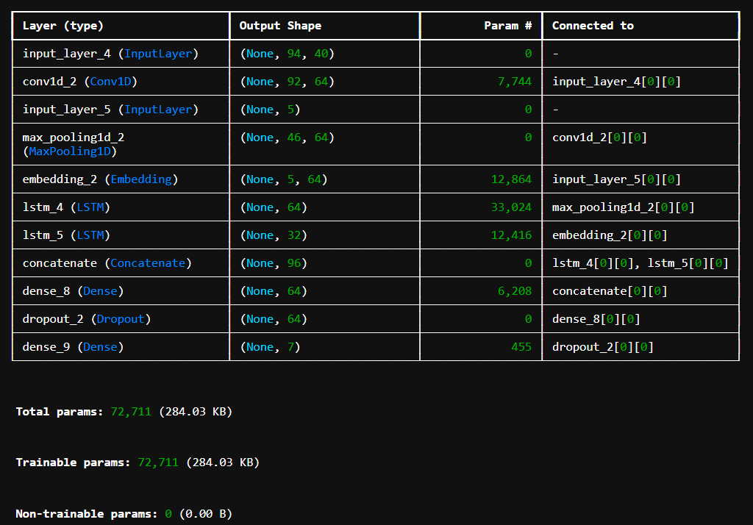

Accuracy Output
